Preview of table reports before normalization:

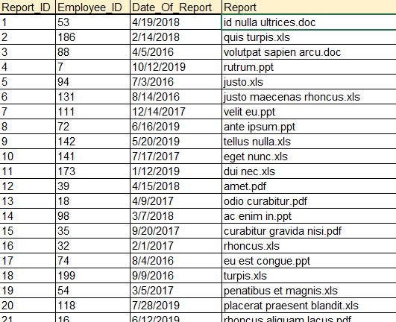

1NF, 2NF, 3NF

PK is report_ID

FK is employee_ID

Entity is in 1st, 2nd and 3th normal form. There is no repeating data, no transitive dependency. It’s all depended on PK.

Preview of table after normalization:

